**Research Documentation**

*( Pre trained model for images )*

|  |  |  |  |  |  |
| --- | --- | --- | --- | --- | --- |
| S.No | Image Pre-Trained Model  (25 epoch) | Training Accuracy | Training Loss | Validation Loss | Validation accuracy |
| 1 | Resnet18 | 99.18 % |  | 0.0313 | 99.24% |
| 2 | densenet121 | 97.72 % | 0.772 | 0.0804 | 96.80 |
| 3 | VGG16 | 87.61% | 0.3449 | 0.3924 | 84.21% |
| 4 | Inception Model | 99.23 % | 0.0278 | 0.0183 | 99.47% |
|  |  |  |  |  |  |
|  |  |  |  |  |  |

**DenseNet121 Pretrained model**

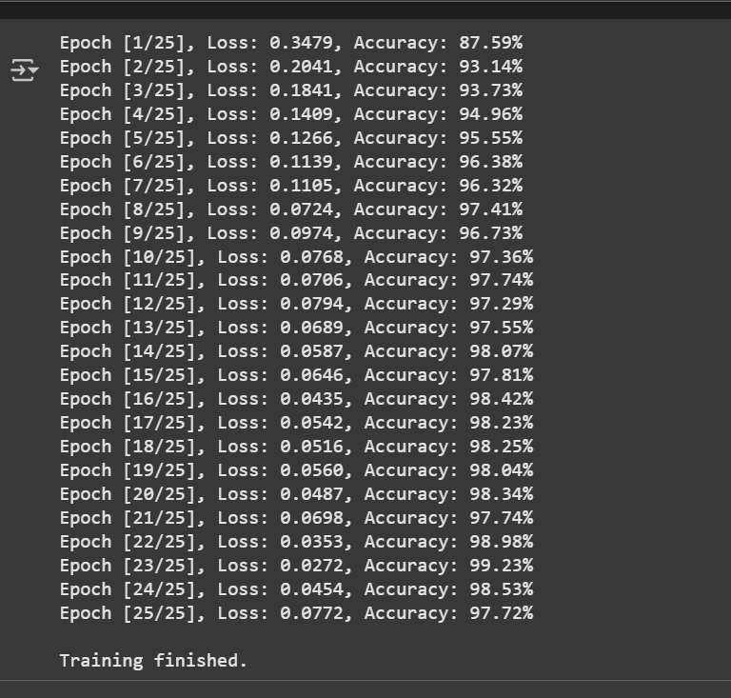

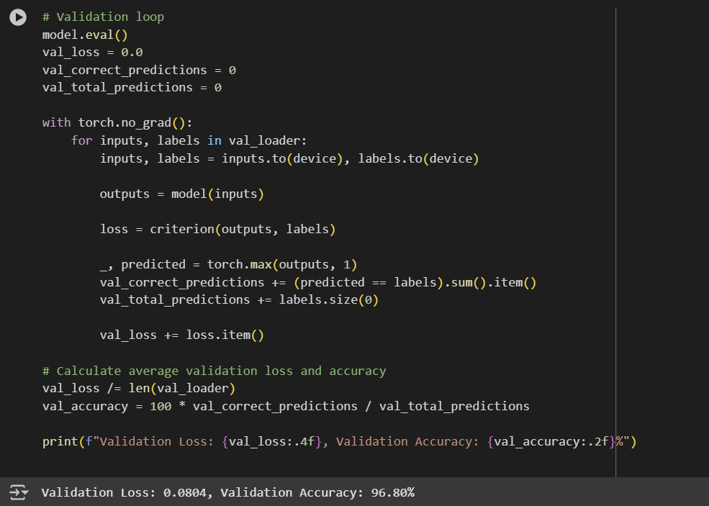

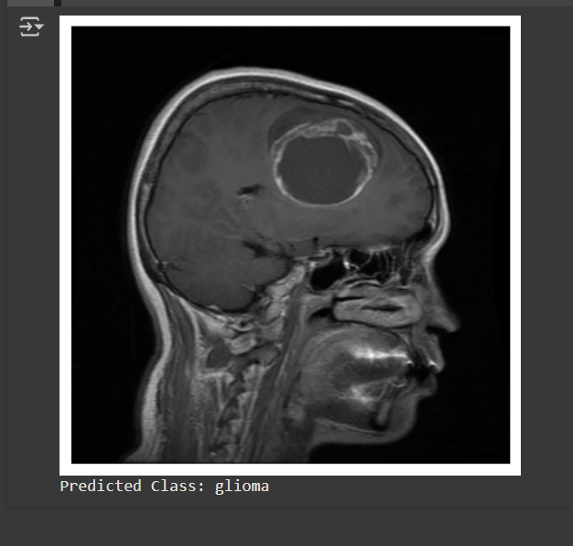

**VGG16 Pretrained model**

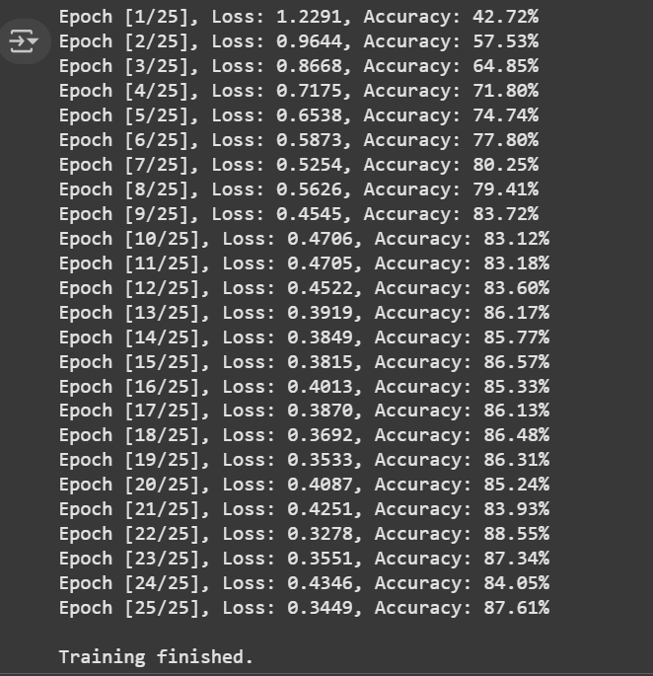

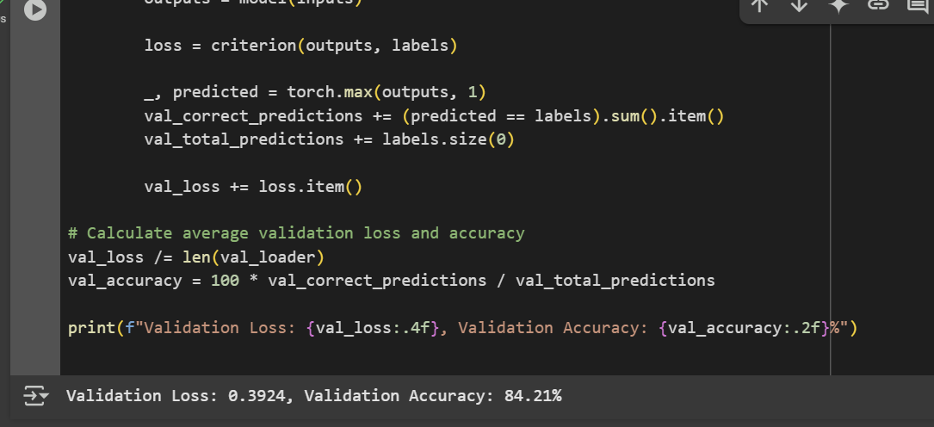

**Inception Model**

**Training**

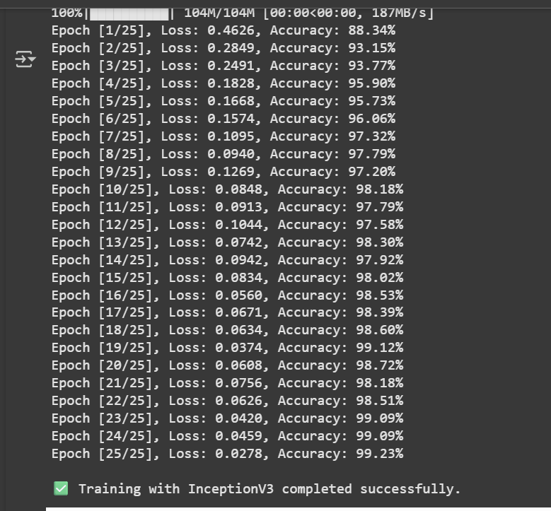

**Validation accuracy and loss**

